Separate the stuff (Science)  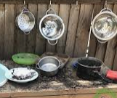  Separate ingredients like flour & rice by sieving  or pasta & sugar using a colander. Use words like ‘too big’ and ‘same’ and ‘not the same’ | Kitchen art (Art/DT)  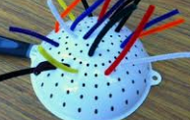  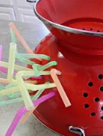  Make a sculpture using spaghetti and a colander or try poking pipe cleaners into the holes.  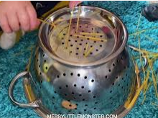 |  | Shake it (Music)  Make shakers by putting dried food into plastic bottles or cups. Make 2 of each and try to match the ones that make the same sound.  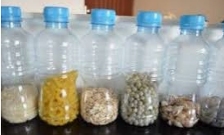  Sing along with this song  https://www.youtube.com/watch?v=qlWVK_-MV9A |  | Feeling feet (Physical)  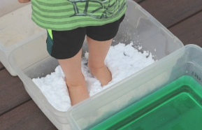  Put cereal, rice, pasta into trays and feel them with your feet. Decide which ones feel nice. Can you draw shapes or letters with your feet?
Silly eating (PSED)
Choose what to eat with – try eating soup with a fork or using a cup to cut your fish fingers. Match the right equipment to the right task
What’s the difference? (Science)  Food, glorious food  -dry food/wet food  Add water to dry ingredients and notice the change –  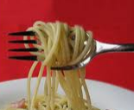  Pasta will go soft  Sugar/salt will dissolve  Custard powder will change colour  Cornflour behaves very strangely!!  What else can you fin |  |  |  | Make meatballs (Physical)  Use playdough or (flour & water dough) to make food shapes. Can you make a meatball then make it follow this song?  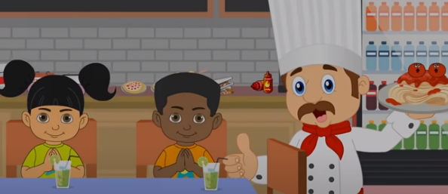  https://www.youtube.com/watch?v=yU2GqcjJcdM |  | Sorted!! (Maths)  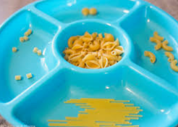  Sort different shapes or colours of pasta into separate containers. Talk about the shapes using words like long, short, straight, fat, thin.
Pizza plates
(Art)Draw or collage your favourite vegetables and food on a paper plate. Make it look like a pizza. Remember, you need some healthy choices!!
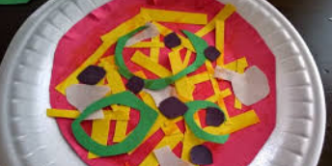
Feel the rhythm, feel the rhyme (English)  Can you say this poem (or listen) as dramatically as this girl?  https://www.youtube.com/watch?v=mrhFbNzsyJg |  | Have a go and keep in touch  If you have a go at any of these activities we would love to see what you do. Send a picture or video to stlukes@stlukesprimary.com It may appear in our gallery on the website. Have a look at http://pupils.stlukesprimary.com/gallery.html

