Play food & Camping  You could use some of your pots and pans.  You could use real food or play food.  Any stones and sticks from the garden to create a pretend fire?  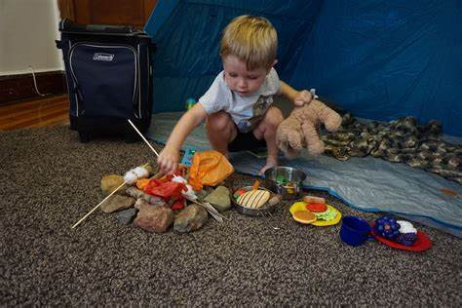  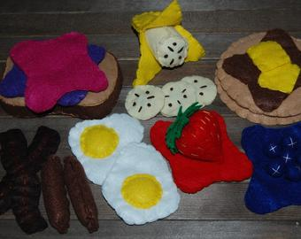 | Den Building!!  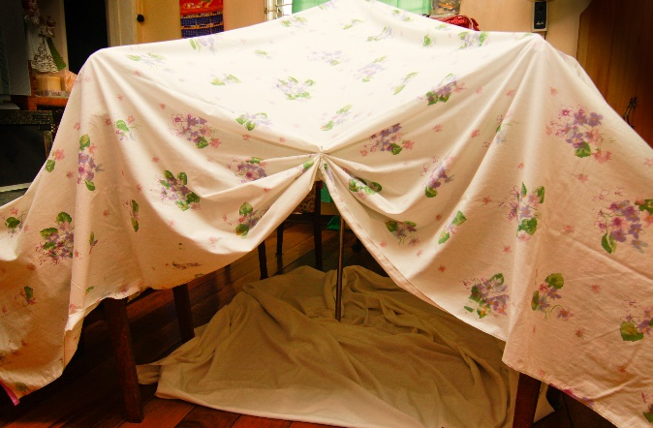  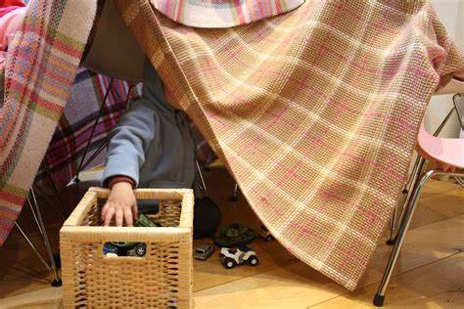 |  | Hot Chocolates  For children to support in making the hot chocolate  -Spoon out the chocolate mixture, pour the milk, mix together.  (Add yummy toppings of your choosing)  OR  Sensory opportunity to try new flavours and textures. Ingredients on their own or together. | Camping Corner  Use bedding or camping equipment such as a sleeping bag to make their den or an area of the room cosy.  Sit down and enjoy a story or watch Clare’s Going on a Bear Hunt video.  (You can access this from the school website)

Coco Powder Mark Making

You can use the coco powder from the hot chocolates to mark make!!

And it will taste delicious too 😊
Torches and light toys  Enjoy exploring the effects of various light toys within your dens.  Can you make shadow puppets?  Can you follow and track the lights?  Can you recognise colours?  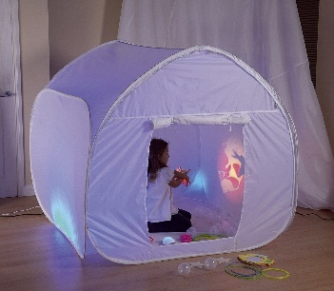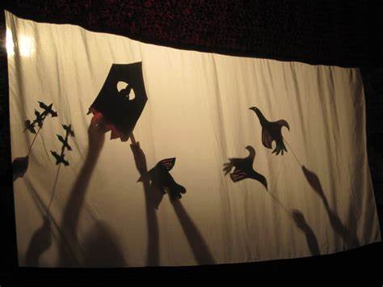 |  |  |  |  | 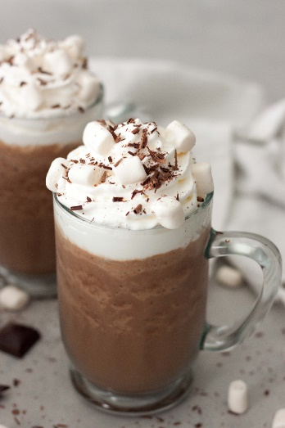
Have a go and keep in touch
If you have a go at any of these activities we would love to see what you do. Send a picture or video to stlukes@stlukesprimary.com It may appear in our gallery on the website. Have a look at http://pupils.stlukesprimary.com/gallery.html

