Wind  Make a kite; use the wind to fly the kite. A plastic bag or balloon attached to string will also work.  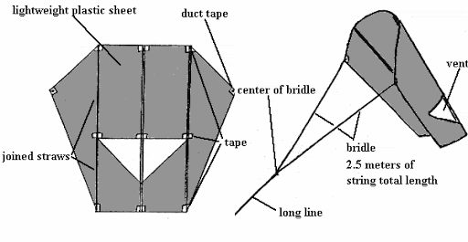  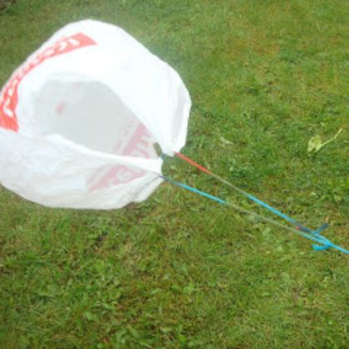 | Rain  Listen to the rain on an umbrella  Splashing in puddles  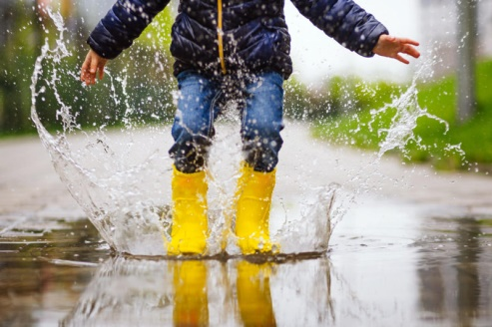 |  | Biscuits decorating  Ingredients  125g icing sugar  2 teaspoons milk  2 teaspoons golden syrup  1/4 teaspoon almond or vanilla extract  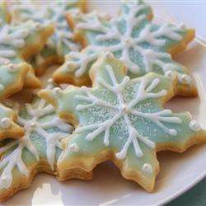  food colouring (optional) | Mark making in mud –  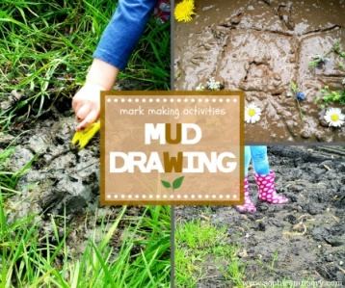  find twigs and mark make in wet or dry mud. Mark making
Collecting, counting, sorting or posting twigs and leaves
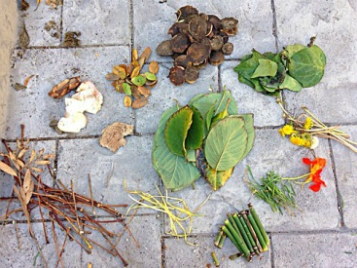
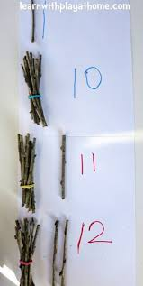
Wind play,  Enjoy exploring the effects of the wind with different fabrics.  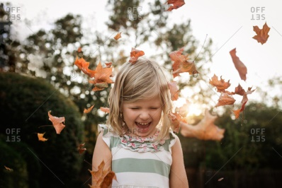  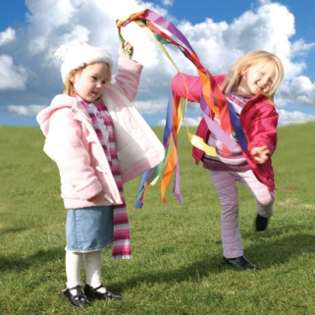  Use leaves to explore with the wind. |  | Weather |  |  | Building little dens or shelters for bugs/ animals. 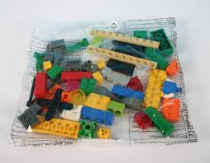
Have a go and keep in touch
There will be additional activities here: http://pupils.stlukesprimary.com/
If you have a go at any of these activities we would love to see what you do. Send a picture or video to stlukes@stlukesprimary.com It may appear in our gallery on the website. Have a look at http://pupils.stlukesprimary.com/gallery.html

