Can they build house for the Tiger  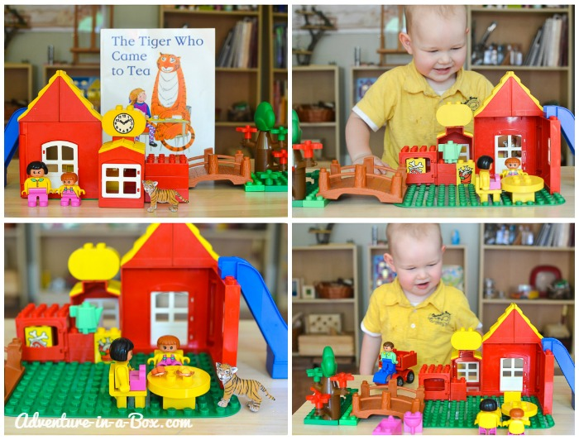  Can they use Bricks to build a home for the tiger?  A doll house can be used for this activity too if you don’t have bricks.  This could also been done using cardboard, If you’re feeling creative. | Cutting and sticking activity.  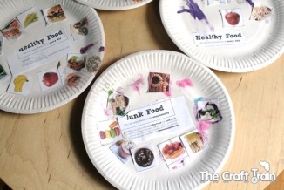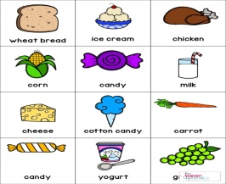  A cutting and sticking activity is really good for fine motor development. You can create your own plate and use pictures online or from magazines or different packaging. Can they hold a pair of scissors? Can they cut out a shape? Can they identify food in a picture? |  | 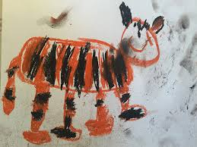  Can they Draw/ colour a tiger? Can they paint a hand print v’s a paw print? Explore Mark making with Black and yellow paint.  Free printable pictures on colouringhome.com. | The Tiger who came for tea story  Watch the story on you tube.
Listen to animal noises
Walking through the Jungle is a great listening activity. You can find this on you tube. (Super simple learning is a lovely listening song.)
Can they name the animal sounds
Sing the Tiger Rhyme
I’m a tiger stripped with fur
Don’t come near or I might GRR
Don’t come near or I might GROWL
Don’t come near or I might …Bite.
( Use the tiger fur as a prop if you have some)
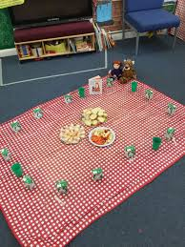

The Tiger Who came for tea picnic.

Have a picnic with the children. Can they find named items, Like;, spoon, cup, plate etc. encourage pretend play. Can they feed the tiger and his friends?
Can they pour a big drink for the Tiger and a little drink for themselves? Can the Tiger have a big plate and they have a little plate?

Can you make a sandwich  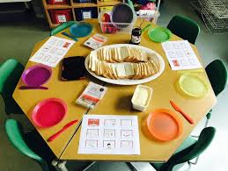  Can the children have a go at making their own sandwich? Or try new foods? Have range of new foods out that they don’t normal eat and encourage them to try it. |  | The Tiger who came for tea |  |  | Playdough Cakes for the tiger.  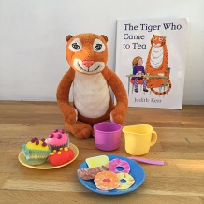  Can they make cake shapes, using playdough  And give it to the tiger.
Have a go and keep in touch
There will be additional activities here: http://pupils.stlukesprimary.com/
If you have a go at any of these activities we would love to see what you do. Send a picture or video to stlukes@stlukesprimary.com It may appear in our gallery on the website. Have a look at http://pupils.stlukesprimary.com/gallery.html

