Move more  Challenge yourself to move more  -do the bleep test  -ride a bike/scooter  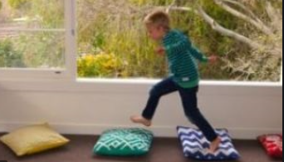  - Make a simple circuit - can be done with PE equipment in school or things around home, step up and down on the first step of the stairs. Jump or step over a cushion. Can be timed to challenge, or just complete the circuit 3 times.  -try Sherbourne movement  https://www.sherbornemovementuk.org/about/sherborne-developmental-movement/  and  https://www.youtube.com/watch?v=2ZuQheTXnv8  Ready, steady, go  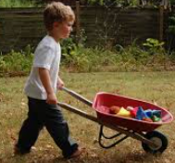  Get moving https://www.youtube.com/watch?v=Jd7p857oiVk  Wheelbarrow race! (children’s barrow) How many objects can you put in your barrow? 1  minute/2 minutes etc.  Read ‘Giraffes Can’t dance’  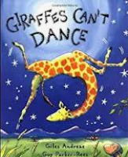  https://www.youtube.com/watch?v=Zzb5Acl-n70  What music makes you want to dance? Send us a video. | 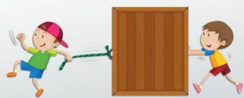  A push me pull you  Have a tug of war. What material can you use to tug? Toilet roll. String, washing line, wool, skipping rope?  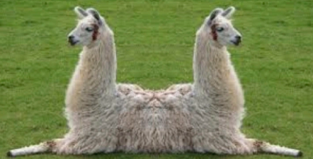  Look at the push me pull you animal. Can you make your own? If you make it from 2 different animals which would win the pushing and pulling?  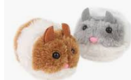  Things that move -likes and dislikes (like the ring pull mice)  How do you like to move or be moved - fast/slow/smooth/bumpy?  Can you make things move - ribbons, parachute, ball, pressing a switch? | Musical moves  Exploring different sounds using a wooden spoon or drum stick - tap on things in & outside ie fence, dustbin, can you follow a rhythm, go fast slow loud quiet? Can you tap to a well know song or rhyme  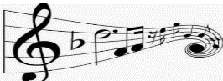  Can you move to this song https://www.youtube.com/watch?v=pn6iOvJzRm0- try to match the pace - can you crawl or jump too? |  | Paint on the move  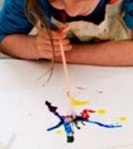  Move wet paint with straws or a fan.  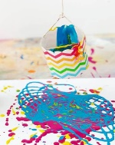  Hang a bottle of paint and push to make it swing to create patterns (maybe do this outdoors!!)  Drop some fairly runny paint onto the top of a piece of paper then attach it to a board or fence with a drawing pin in the middle of the paper. As the paint runs down turn the paper to make the drip patterns change direction.  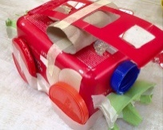  Design and make a moving vehicle out of junk modelling  Build a train track  Print different toy wheel tracks
Push off!!
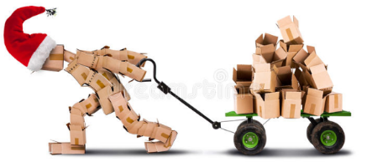
Fill a box with heavy things. Draw/tape 2 lines on the floor. How many ways can you find to move the heavy box. Use different textured surfaces. Which way was fastest/easiest?

Use pulleys to make Jack & Jill go up the hill or Humpty Dumpty fall off the wall (the beams in school are good for this)

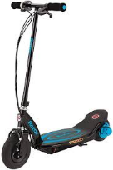
How do different animals move- show us!
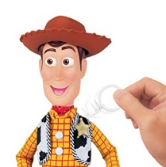
How do toys move? Which ones do you push? Which ones do you pull?

Challenge! Can you make a list of those you would push and those you would pull? Choose your favourite and write instructions.
 | Move it challenge sheet |  | Have a go and keep in touch  If you have a go at any of these activities we would love to see what you do. Send a picture or video to stlukes@stlukesprimary.com It may appear in our gallery on the website. Have a look at http://pupils.stlukesprimary.com/gallery.html
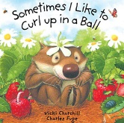  English  Read  Sometimes I like to curl up in a ball https://www.youtube.com/watch?v=vj5pGV3IqWY  Do the actions. What actions would you put in your story? How would you describe them. Fill in the gaps  I like to…… like a ……  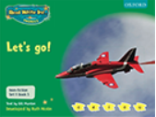  You might like to read these books  Oxford Owls: Let’s Go (vehicles)  Oxford Owls: Sports is Fun www.oxfordowl.co.uk  Describe movements - can you understand the words in the writing patter? Listen to the movement words to draw letters (which sound did you draw?)  Use ribbons/scarves to make letter shapes in the air. (Big and small movements)  Draw letters on large sheets of paper and use water balloons in tights to splat named letters! Dip the tights in paint/water? Sound out a CVC word and encourage children to splat the word.  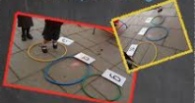  Place 3 hoops on the floor and put a grapheme card in each one. Can they jump in the hoop, say the sounds and blend to make the word? Children move letter cards to make new CVC words. | Maths  Read Rosie’s walk  https://www.youtube.com/watch?v=aynZh1-fsBg  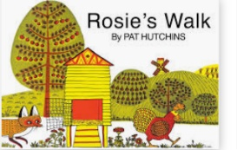  Practise using your positional language by getting physical – on, under, next to the table, shed, chair etc.  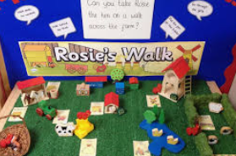  Use doll’s house or toy farm to practice understanding these words  Work on direction, taking turns to give directions to a place or object ie left, right, 2 steps forward estimate how many steps to get to the kitchen. Use BeeBots in school.  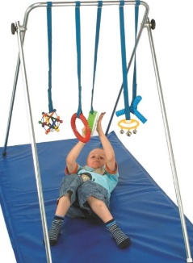  Container play - moving items from one place to another, posting into different containers (colour and shape sorting)  Swiping hanging objects suspended on A frame/hoists  Use drain pipe + cars/balls- how many skittles did they knock down? (put colours/numbers/faces/shapes on the skittles.  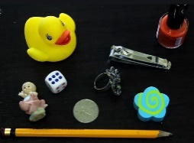  What did I move? - use a tray of items or a familiar area. Don’t look & get someone to move one item. Can you spot what has moved? Did it move a long way or just change position? What words can you use to describe this? |  | Life Skills  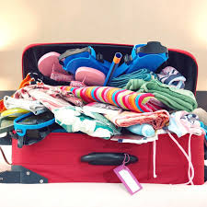  What would you pack for a holiday to a hot place? What would you pack for a holiday to a cold place?  Sort the clothes to match the weather! Use your own clothes or these:  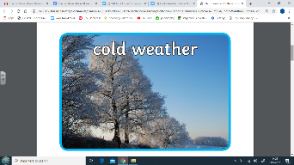  https://www.twinkl.co.uk/resource/t-t-24926-new-photo-weather-clothes-sorting-activity  Challenge! Choose a hot place and find out about it. Write down five facts.  Sensory  Move over a range of different outdoor surfaces e.g. woodland trail, grass, shingle, cobbles.  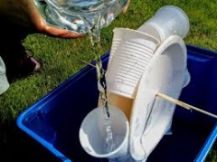  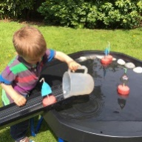  Water play. Can you make the wheel or the boat move?  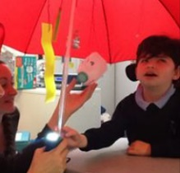  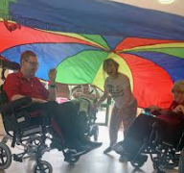  Parachute Games - Moving parachute in different ways, moving over and under parachute. Making things bounce on parachute.(can use bed sheet or umbrella for paired work) .

