Fish out of water–Maths  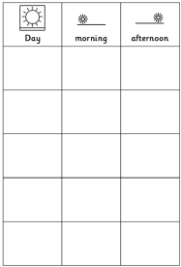  Cut out the fish below. This fish wants to spend time where you live.  Make him a timetable by ordering the days of the week on the sheet below and deciding where he can go each morning or afternoon.  Remember to keep checking so you can take him where he needs to be.  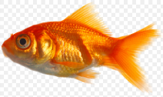 | Magic carpet ride to the sea  (part 2) | Listen - English  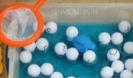  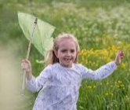  Use a fishing net (a bag will do) and get your family to tell you something to collect. Can you get it in your net quickly? Can you remember a list of 2 things or 3? What about ‘fishing for things beginning with ‘s’(spoon, soup, scissors, sandal). See what you can find. Remember to listen carefully – your family might try to trick you. Perhaps you could fish for letters and see what words you can make. | 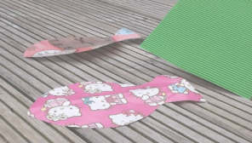  Flap the fish – PE  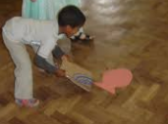  Cut a fish out of wrapping paper or a page from a newspaper or magazine. Use a magazine or paperback book to flap the fish along the floor. Make a start and finish line.  Race your family. You could make a ‘river’ to flap the fish along using cushions and toys as the riverbank.
Wishes for fishes English/PSED  Read this story https://www.youtube.com/watch?reload=9&v=nIfc9lsZPLQ  Use the thought bubbles below to write (or stick pictures) of the things you would wish for.  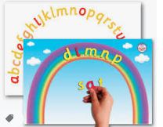  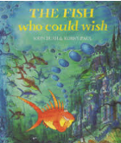  Read the story again and listen for words that rhyme. If you think really hard you could wish for things that rhyme. Can you make rhyming words by changing the first letters? | Fish tails – Maths/DT  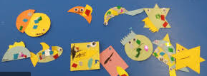  Draw round some shapes - box lids and beakers are good. Remember to keep your pencil touching the edge. Cut them out carefully then match different shaped bodies with different shaped tails. If you have split pins you can make them move. Mix & match and see how many different fish you can make. Can you name the shapes e.g. a triangle and a semi-circle. | Sea shanty Music  Nathan Evans has taken TikTok by storm. https://www.youtube.com/watch?v=WHbU6s0jANc Everyone is learning sea shanties. Can you drum along using anything you can find? They used the rhythm to haul in the nets. What makes the best sound? a plastic box or a wooden table.? A biscuit tin or a cushion?  Learn the words to ‘What shall we do with the drunken sailor & drum along. Can you hold the rhythm? | Creative creatures – Art  Start with a tiny bit of blue paint and add white. Paint wave shapes in the different shades you create. Try adding yellow or a speck of black to create different shade of green or blue. Does your painting look like the sea?
Salt water –Science  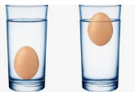  Do you know things float more in salty water? Try this experiment. Carefully put an egg into each bowl of water? What happens? Stir 1 spoonful of salt into one bowl of water. Add the egg and see what happens. How many spoonfuls of salt did you add to make the egg float?  Adults -Objects float better in salt water than in fresh water because salt adds mass to water and makes it denser. Adding 10g of salt to 100g of water, gives a total total mass of 110g. The denser the water, the easier it is for objects to float on top. | Dress to impress - PSED  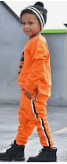  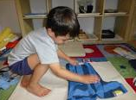  Look in your drawers & wardrobe. Can you choose an outfit in sea colours or one that makes you like a fish? What about sandy colours? Can you put them on and take them off with only a bit of help? Can you fasten & unfasten them?  Try folding them into piles of similar colours. | Squishy fishy- DT  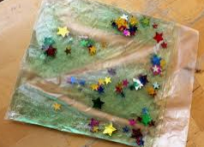  Make a sensory sea bag. Use a ziplock bag and some hair gel. Tip the hair gel in and add some plastic creatures or ones you’ve made out of plastic packaging.  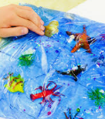  Seal it well and squish to make the creatures move around. | Have a go and keep in touch  If you have a go at any of these activities we would love to see what you do. Send a picture or video to stlukes@stlukesprimary.com It may appear in our gallery on the website. Have a look at http://pupils.stlukesprimary.com/gallery.html
