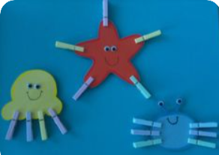  Sea creatures–Maths/Fine Motor  Cut out the bodies of some sea creatures from paper or card. An adult will write a number on each and you have to put the correct number of ‘legs’ on using clothes pegs. Can you find two with the same number of legs? Maybe you can add them up e.g. a starfish and an octopus have 5+8 legs. How many altogether? | Magic carpet ride to the sea  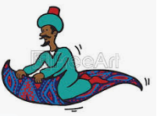 | Float or sink Science  Gather some objects from your house e.g. a plastic bottle, a ball, a spoon, a coin, a plastic cup, a stone, a key. Guess which ones will float and which will sink. Try dropping them into a bowl of water. Were you right?  Find out why this happens here.  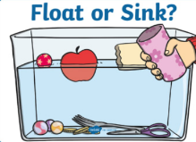  https://www.youtube.com/watch?v=2dyCe1GPagE | Sea games – PE  Port/starboard Play this timeless game  https://www.onlinescoutmanager.co.uk/programme.php?action=view&id=52652  You could label port and starboard with their colours; port-red, starboard – green to help.  Can you move like sea creatures? Jump and turn like a whale, move sideways like a crab, slither like an eel.  Catch my tail. Everyone tucks a scarf into their waistband at the back. You have to try to grab each other’s fishtail. If you lose your tail you are out!
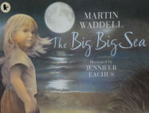  The Big, Big Sea English/PSED  Read this story and look carefully at the pictures. You could make this a sensory story by putting your feet in the water and smelling or eating hot buttered toast. What else could you do from the story?  https://www.youtube.com/watch?v=VGWjiVnHJxM Point to - a picture? A word? A letter? A full stop? A capital letter?  How does this story make you feel? Happy, sad, calm, excited, cold? Can you say why it makes you feel that way? | 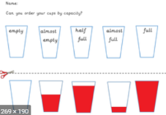  Capacity – Maths  Find some clear containers (plastic boxes or cups). Carefully pour water (adding some food colouring makes this easier to see) into each one making one full, one empty, one half full, one almost full and one almost empty. Can you put them in order from emptiest to fullest? Try these activity cards to learn more about capacity and volume.  https://www.twinkl.co.uk/resource/t-n-4288-ks1-capacity-challenge-cards | Sea sounds Music  These pieces of music are written about the sea. Use a scarf or ribbon and move it to the music. Does it remind you of the waves?  https://www.bbc.co.uk/programmes/articles/3Fm3H66YnxNZslLrSX3mMvh/top-six-sea-pieces  Which ones sound stormy? Which ones sound calm? Which of the pictures (see below) would you choose when you listen to each piece?  Use a drum, shaker or saucepan & wooden spoon to make calm rhythms and stormy ones. | 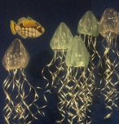  Creative creatures – Art  Make some sea creatures with whatever you have in your house. Plastic bags or shower caps and ribbon or shredded carriers make great jellyfish.  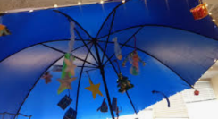  Rubber gloves can be an octopus or puffer fish. Cut out starfish. Try hanging up an umbrella and dangle your creations. They will look like they are swimming
Healthy oceans -Science  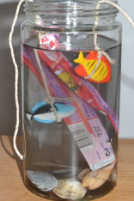  https://www.science-sparks.com/sea-pollution/ Try this activity to see why we need to keep our rubbish out of the sea.  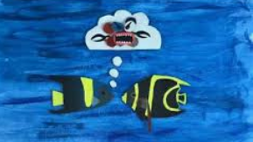  Listen to this story and think about what you can do to help the sea creatures  https://www.youtube.com/watch?v=tlU3eUgDYqc | Shape poem– English  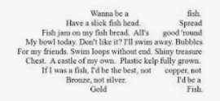  Look at the poem below in the shape of a jellyfish. Can you write a poem (or copy the poem on the page below – maybe just some key words) onto a sea shape. A wave or a fish or even a boat. | Foil fish- Art/writing  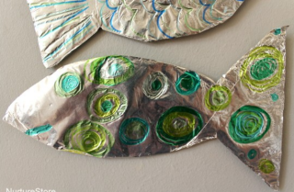  Make some foil fish. Use sharpies, or mix some PVA with your paint to make it stick. You could practice your writing patterns on these.  https://nurturestore.co.uk/foil-fish-craft-ocean-theme-preschool  Hang them near the window to catch the light as they ‘swim’. | Have a go and keep in touch  If you have a go at any of these activities we would love to see what you do. Send a picture or video to stlukes@stlukesprimary.com It may appear in our gallery on the website. Have a look at http://pupils.stlukesprimary.com/gallery.html
