Fly trap– DT/ Maths  Make a frog using round shapes – circles, semi-circles and spirals.  See if you can remember those names.  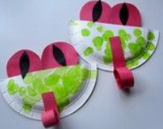  If you have a party blower, it would make a great tongue. | 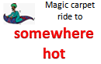 | Layers of the rainforest -Science/Maths  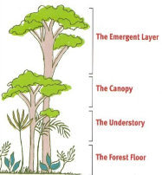  Can you learn the name of the layers? Cut some pictures out of animals and plants you would find in the different layers. Make a pretend jungle on a tray and use your prepositions to describe where the animals (toys or pictures) go.  On the tree, in the bush, under the ground, behind the tree, next to the monkey | Jungle jig – PE  Join Nala & Simba to keep fit  https://www.nhs.uk/10-minute-shake-up/shake-ups/jungle-jig-with-nala-and-simba  or join the lionesses  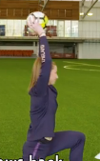  https://www.nhs.uk/10-minute-shake-up/shake-ups/simbas-jungle-skills
Big mouth!! English  Read this story about a frog  https://www.youtube.com/watch?v=i79IByX4_DI  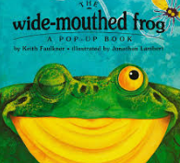  We think it’s a funny story. Do you? | Crocodile Crazy English  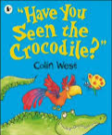  https://www.youtube.com/watch?v=XQAMJJlBHqE Listen to this story.  Can you remember the animals in order? Hide some toy animals (or pictures) in your home and give people clues so they know where to find them. Look at the page with all the animals on. Ask an adult to name them and point to them in any order e.g. ‘bee, frog, bird’ The adult will mix it up so it’s tricky. How many can you remember at once? | Rain forest sounds Music/DT  Listen to the sounds of the rainforest  https://www.youtube.com/watch/8myYyMg1fFE  What can you hear?  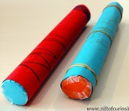  Can you make sounds like these – use a whistle or a recorder. Try pouring rice or popcorn kernals into a tray or plastic jug.  Make a rainmaker. Find instructions here  https://www.giftofcuriosity.com/diy-rain-stick-craft/ | Hot or cold- Art/PSED  Mix some paints or tear some coloured paper and make a picture with hot colours on one side and cold colours on the other.  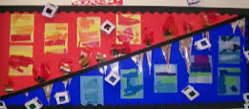  Can you sort your clothes into hot and cold colours? Try hard to fold them neatly.
Get the feels -Science/PSED  Use the symbols to label things in your house that are hot or cold.  Watch this video for ideas.  https://www.youtube.com/watch?v=sz1vY2VrBD0  Can you have a hot dinner (e.g. soup) and a cold pudding (ice cream)?  or  A cold dinner (salad or sandwich) and a hot pudding (rice pudding).  Can you use cutlery to help make it and eat it yourself? | 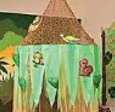  Jungle experience – Art /Music  Find a piece of material/old sheet and make a canopy over your head. Attach some streamers (cut up plastic bags -especially green ones- are good for this). Attach some bright flowers.  Sing this song as you move in and out of your ‘jungle canopy’  https://www.youtube.com/watch?v=2o332s5Hl0c | Paper parrot - Art  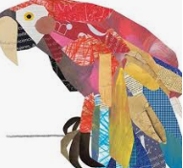  Can you use scissors to cut feather shapes from coloured magazines or paper. Use them to make a colourful parrot. Can you name the colours?  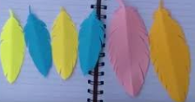  If you are very good with scissors you can snip the feathers to make them curl out | Have a go and keep in touch  If you have a go at any of these activities we would love to see what you do. Send a picture or video to stlukes@stlukesprimary.com It may appear in our gallery on the website. Have a look at http://pupils.stlukesprimary.com/gallery.html
