Roll up, roll up– DT/PSED/Maths  Make some pancake rolls following this method  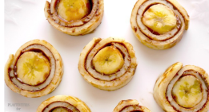  https://kidsactivitiesblog.com/61826/pancake-roll-ups-kid-style/  Count how many you have made. How many people live in your house? See how many they can have each (put 1 on each plate and repeat until they are all gone). You can write that as a number sentence 2+2+2+2=8. Have you got any left over? | Magic carpet ride to China  with added pancakes! | Bigger pancakes. How? Science/Maths  Follow this experiment to see why some pancakes are bigger and fluffier.  https://www.science-sparks.com/the-science-of-pancakes/  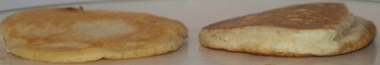  Can you order them in size and name the biggest, smallest, thick, thin, or find one bigger than the second one? These are good concepts to learn. | Ribbon dance – PE  Use a scarf or long piece of fabric or crepe paper for a ribbon. Watch these children  https://www.youtube.com/watch?v=lD-cIjFrZyg . Can you make up a dance like theirs?  Listen to this Chinese music  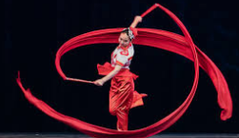  https://www.youtube.com/watch?v=v5B4e79bmCs  Move to the rhythm.
The year of…- English  Listen to the story of how the Chinese years got their animals  https://www.youtube.com/watch?v=eVClAj8q_lY  This year is the year of the ox.  Can you find some of your soft toys and act out this story with them. Tell your family the new story. Make a list of the animals and the position they came. You can use pictures or words.  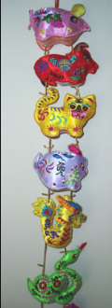 | Money, money, money Maths  For Chinese new year people give gifts of money in red envelopes. Write an amount (e.g. 8p) on an envelope and see if you can make the same amount by  -counting out 1p pieces until you reach the correct number  -matching a set of coins  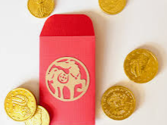  -adding up how much is in the envelope and making the same amount with different coins  -do you know how many 2p pieces make 8p | A-and relax Music  Find a quiet space, shut the curtains (maybe an adult will light a candle), lay down and listen to this music  https://www.youtube.com/watch?v=Xb3dOy6SUKU  Bend and stretch your fingers and toes and see if you find this music relaxing. What sounds can you hear? | Cherry blossom- Art/PSED  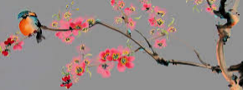  Paint or cut out a black tree or branch outline on some paper. Add blossom by mixing red and white paint (what colour do you think it will make?) and ‘dotting around the branches. You can use your finger or a cotton bud.  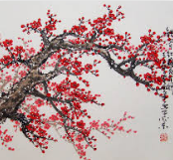  Perhaps you could use some pink tissue and glue it on.
In the shadows -Science  Try this experiment  https://www.youtube.com/watch?v=yqmXAm1Cw3k  Chinese shadow puppets are used to tell stories. Can you make some puppets and tell a story?  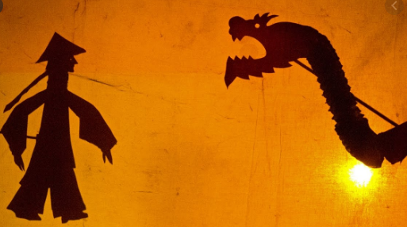 | Dragon poem– English  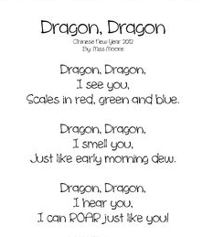  Read this poem and think of words to describe how a dragon might look, smell and feel. Find a picture of a dragon and put your words around it. Then think about how you would feel if you met a dragon. Put your words on a picture of you. | Fans & lanterns- Fine motor  Fold a piece of paper or thin card in half lengthways and cut straight lines from the folded edge to 1cm from the other edges. Tape or glue the short sides together to make a lantern  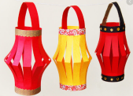  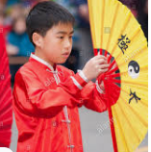  Fold over the short edge of a piece of paper or thin card (about 1cm then turn over and fold again. Repeat until the end. Tape one long edge together and you will have a fan. Do a Chinese fan dance!! | Have a go and keep in touch  If you have a go at any of these activities we would love to see what you do. Send a picture or video to stlukes@stlukesprimary.com It may appear in our gallery on the website. Have a look at http://pupils.stlukesprimary.com/gallery.html
