Max goes to the Moon  Click on the link and listen/ watch the astronaut read the story ‘Max goes to the Moon  https://storytimefromspace.com/stories/max-goes-to-the-moon/  Can you retell the story afterwards?  Can you draw a picture of the main character? | To infinity  and beyond  w/b 25th January 2021 | Star Gazing  Go outside together on a clear night and look at the stars. Can you see the moon? What phase is it in? If you feel able to, look at different constellations of stars. Take some photographs. Warm up with a yummy hot chocolate when you come inside.  Go out each night at the same time and draw what the moon looks like, Keep a moon diary for a month. | Pizza Moons (Life Skills)  Make pizza dough from scratch or use a wrap or a ready-made pizza base. Then add mushroom moon craters, cheesy moon dust and ham space rocks.  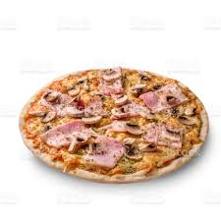
Moon sand (Sensory)  Mix flour and baby oil to create mouldable sand. Add as many different colours as you like.  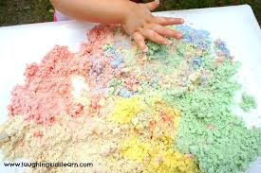 | Fizzy moon rocks (Science)  Use bicarbonate of soda with food colouring and glitter then add vinegar to make them fizz!  https://littlebinsforlittlehands.com/fizzing-moon-rocks-activity/ | Reading Moon Rocks (English)  Make shiny rocks by wrapping objects in foil. Write a word or a letter on each one with a marker. Read the word and put them together to make a moon related sentence.  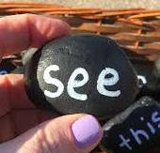 | Bumpy paint moon (Art/ DT)  Instructions for how to create a puffy paint moon using glue and shaving cream. https://www.notimeforflashcards.com/2009/05/lunar-landing.html  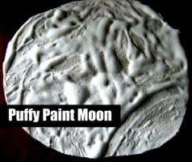
Moon Phases (PE)  Draw pictures of the 4 moon stages. Stand in the middle. Ask someone to name one of the phases. Jump to face the stage. Repeat with different ones – how quick can you go?  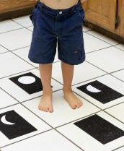 | Learn to Moonwalk  Watch the video and learn to moonwalk. https://www.youtube.com/watch?v=JCfDQzMkENw Have a family challenge – who can do the best moonwalk? | Moon maths  Draw a moon and put a selection of different numbers in the craters depending on child’s ability. Find some small objects to place over the numbers when they answer a question correctly. This could be matching numbers, or reciting multiplication tables. IF you have more than one child at home, each one could have a moon and then race to answer the questions correctly first.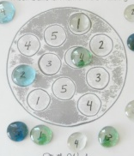 | Have a go and keep in touch  If you have a go at any of these activities we would love to see what you do. Send a picture or video to stlukes@stlukesprimary.com It may appear in our gallery on the website. Have a look at http://pupils.stlukesprimary.com/gallery.html

