Matching pairs  Help to match up the socks or pairs of matching pants for the Aliens.  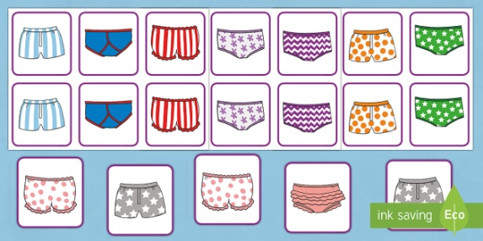 | Make your own Alien  Use toilet rolls paint them bright colours then decorate with whatever you can find around the house. Googly eyes, pipe cleaners, stickers or draw on to make their face.  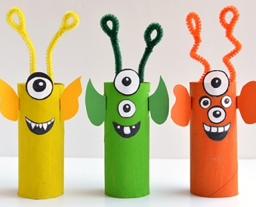 | Alien Addition  Try shooting the correct Alien spacecraft when you have found the answer to the addition question.  https://www.mathplayground.com/ASB_AlienAddition.html | w/b 1st March 2021  Aliens  To infinity and beyond
Stay in your pyjamas and make a reading den to share a story.  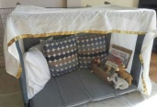  Do any of the other ‘World Book Day’ activities sent out by school and send in your pictures. | Dry your pants  Help to hang up the washing or your paintings to dry using pegs. 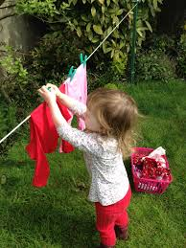  Pretend to be the Aliens borrowing pants from the washing line! | Aliens love Underpants!  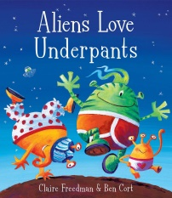  Read the book if you have it or listen to https://www.bbc.co.uk/bitesize/topics/z74n6v4/articles/zbm2qp3 | Pants!  Design your own set of pants for the Aliens to take. Cut out a large paper template or use actual pants if you have any! Paint, print, collage anything to decorate and make as colourful as possible!  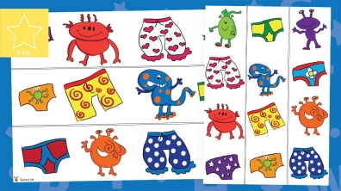
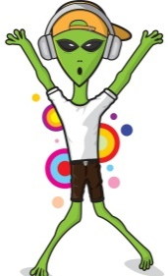  Move like an Alien!  Turn up the space-themed music and do some alien moves! | Have a go and keep in touch  If you have a go at any of these activities we would love to see what you do. Send a picture or video to stlukes@stlukesprimary.com It may appear in our gallery on the website. Have a look at http://pupils.stlukesprimary.com/gallery.html | Find and Communicate with Alien Life!  Draw aliens and hide them around the house/ garden. On the back of each one write ideas about how to communicate with them. – One might tub his tummy and pat his head, another might hop while singing Twinkle Twinkle Little Star.  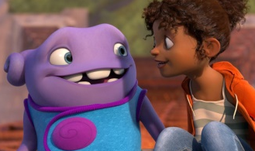 | Make some Alien Goo!  Warning – this is a very messy experiment, make sure you’re wearing clothes you don’t mind getting stained.  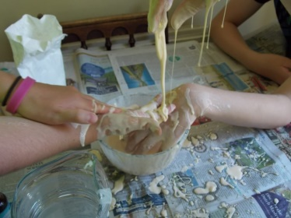  https://fun-science.org.uk/speedy-experiment-alien-gloop/

