5, 4, 3, 2, 1 Blast Off! (Maths)  Practise counting down from 10 by watching  https://www.bbc.co.uk/teach/class-clips-video/maths-ks1-counting-down-from-10/zb4kjhv  Then practise putting the numbers in order using the game https://www.softschools.com/counting/games/counting_backwards_from_20/ | Make a rocket (Art/ DT)  Design and make your own rockets using whatever resources you have available at home. Talk about the design, colours and shapes you will use. Use different effects e.g. splatter paint to make a starry background cut out coloured shapes.  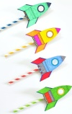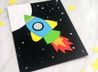  Make rockets attached to straws and have a rocket race. | Five little Astronauts (Musical)  .  Make a musical shaker from an empty bottle filled with lentils, rice, pasta or other grains. Decorate. Sing or chant the astronauts song shaking your shaker along at the same time. | Fruity Rockets! (Life Skills)  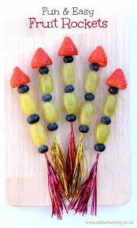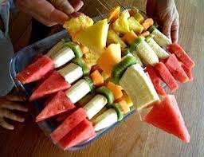  Try some different fruits and make some fruity rockets with your favourites.  *Take care with sharp skewers*
Rocket Maths  Practise rounding numbers to the nearest 10 or 100 using https://www.topmarks.co.uk/maths-games/rocket-rounding  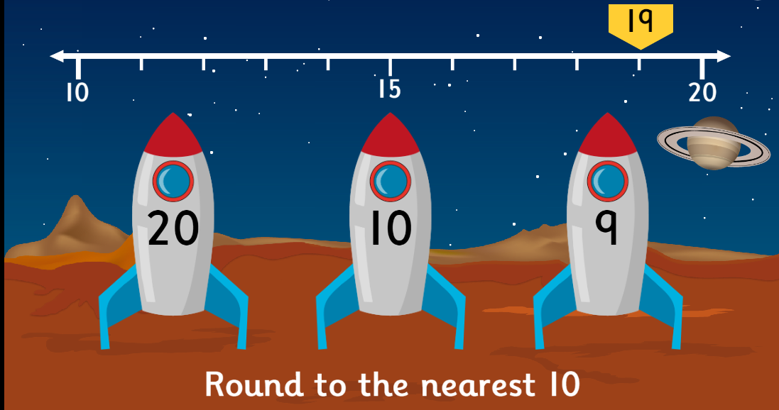 | Spot the difference  Look carefully at the two pictures and find the small differences  https://www.nasa.gov/specials/kidsclub/games/not-same/index.html | Astronaut Training (PE)  Astronauts need to be super fit! Create a personal fitness programme to get your body ready for space adventures. 10x star jumps, 10x squats to avoid the asteroids, hopscotch over the craters etc. | Create your own rocket (Science)  Read the instructions on https://www.science-sparks.com/infamous-coca-cola-mento-trick/  Make sure you go out in the garden and drop the Mentos into the coke bottle before standing well back!  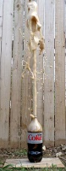
Patterns, patterns (Maths)  Explore, continue and complete different space themed patterns  https://www.nasa.gov/specials/kidsclub/games/what-comes-next/index.html | Rocket Dreams (English)  Listen to the story  https://www.bbc.co.uk/teach/school-radio/audio-stories-rocket-dreams/zfg3scw  Can you make a rocket like Lola’s from aluminium foil and toilet roll? Decorate your own and blast off into space!  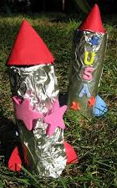 | To infinity and beyond  w/b 1st February 2021  Rockets | Have a go and keep in touch  If you have a go at any of these activities we would love to see what you do. Send a picture or video to stlukes@stlukesprimary.com It may appear in our gallery on the website. Have a look at http://pupils.stlukesprimary.com/gallery.html

