The Four Seasons – Geography/English/Art  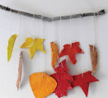  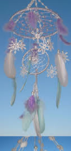  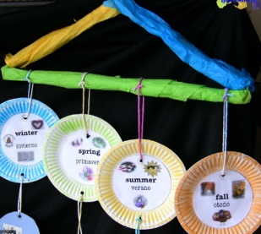  Make a hanging/mobile using things to represent the four seasons. Find warm colours and items for summer and cold colours for winter. Put the seasons in order and think of words for each season. You could make it hanging from a paper plate and make the seasons turn. Think about the months that are in each season. Can you read or write their names? |  | Snip, snip, snip –Fine motor/Art  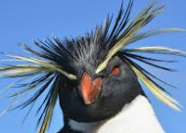  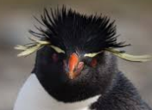  Find out all the names of penguins with crests. Can you snip paper to make a crest for yourself? You could make a penguin hat. How close and straight can you make those snips? |  |  |  |  | Snowball fight – PE/English/  Maths  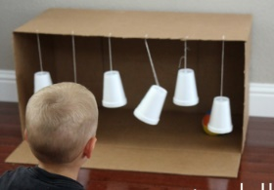  Make paper snowballs and throw at a target (paper cups are good). Add up how many you knock over. Hang some on a string and hit them with your hand. Make a target (post it notes) with letters or numbers and see if you can hit the letters in your name or the number of your house.
 |  | Sing along a penguin – Music  Sing these action songs  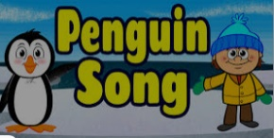  https://www.youtube.com/watch?v=He5Xu11HBkM  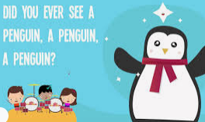  https://www.youtube.com/watch?v=J7E7CIWqEHs  Can you sing them in a high voice, a low voice, fast, slow, loud and quiet? |  |  | What would you do? – Science  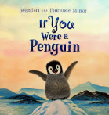  Read  ‘If you were a penguin’ by FF & W Minor  https://www.youtube.com/watch?v=sqSZK_6L0rg  Find out all you can about penguins. What is your favourite thing a penguin can do?
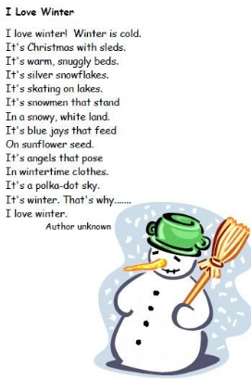
Love it or hate it? PSED/English

Do you love the cold or hate it
Make a chart of things you like or don’t like about cold weather.
Maybe you could make them into a poem like this one.

Ice-ing on the cake- PSED  Decorate some cakes to look like snowmen. Do you know what to use for each task?  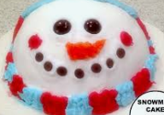  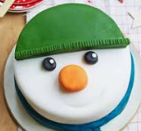  Sieve icing sugar on a tray to make a snowy land. Use plastic animals with wet feet to make footprints. Draw snowflake patterns in the ‘snow’. |  |  | Have a go and keep in touch  If you have a go at any of these activities we would love to see what you do. Send a picture or video to stlukes@stlukesprimary.com It may appear in our gallery on the website. Have a look at http://pupils.stlukesprimary.com/gallery.html
 | Keep your cool – Science  How do we keep things cool? Try putting some ice cubes or ice cream in plastic containers and placing them where you think they will stay cold– outside, fridge, freezer, windowsill, radiator, kitchen. Check on them every few minutes to see if they have melted. Try wrapping the ice cubes in different things, tissue, cloth, foil etc. Does it make any difference? Perhaps a grown up can tell you why some things need to stay cold like milk or meat. |  |  | Polar bear, polar bear – Art  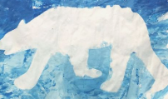  Cut out a bear shape and blu-tak it to another sheet of paper. Use a sponge to print pale colours around it, then remove to see your white bear.  Read Eric Carle’s story and make the sounds.  https://www.youtube.com/watch?v=ehoGdGokXfc

