Animal printing – Science  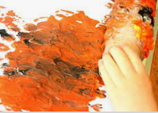  Look at all the jungle animals you can find and sort them into ones that fly or live on the ground. You could sort the big & little ones or sort ones that are plain, stripy and spotty. You can make stripy and spotty animal print by wrapping a rolling pin in cling film then blobbing dark paint on or painting stripes along the length. Roll it over your paper and you will have stripy or spotty animal print. |  | Sequencing snakes–Art/maths  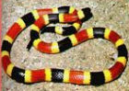  Draw a snake on a long piece of paper. Use your finger to print a repeating pattern e.g. red, blue, red, blue…. How about a trickier one blue, red, red, red, green, yellow, yellow, blue, red….. |  |  |  |  | Face paints – PSED  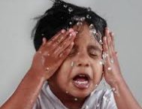  Paint stripes on your face with face paints (or make-up if you are allowed). Do you look like a tiger or zebra?  Now can you wash it off yourself? Look in a mirror to make sure you have reached everywhere.
 |  | Monkey moves – PE  How many laps of your house garden can you do moving in each of these ways?  -swinging your arms like a monkey  -stomping like an elephant  -hopping/jumping like a frog  -prowling on all fours like a tiger  -slithering on your tummy like a snake  -flap your arms like a parrot |  |  | 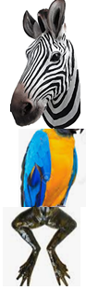  Misfits? – Art  Make a collage of animals using parts from jungle animals.  Give your animal a name. Can you use parts of the old animals’s names?
Roar/hiss PSED/Geography
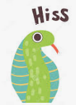
In the jungle, the mighty jungle, the lion sleeps tonight. Vote whether there are lions in the jungle by roaring (yes) or hissing (no).
It is ok to get some wrong.
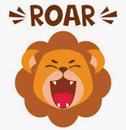
Take it in turns e.g. In the jungle, the mighty jungle, it’s freezing cold tonight. (HISS)
In the jungle, the mighty jungle, the monkey swings tonight (ROAR)
Parents: You might want to use some pictures or symbols to prompt this. Ask your teacher if you do.
https://www.youtube.com/watch?v=5V9v94cPXak
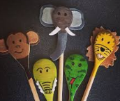
You could make wooden spoon puppets to hold up as you play this game.

Feel the rhythm- Music  https://www.youtube.com/watch?v=rbc_LxfhSoY  Find some shakers (or make some with rice in a jar or cup)  Shake and move in time with the music.  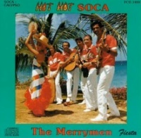  Can you find songs about hot weather or the jungle. How about ‘walking on sunshine’ or ‘jungle rock’. Play along  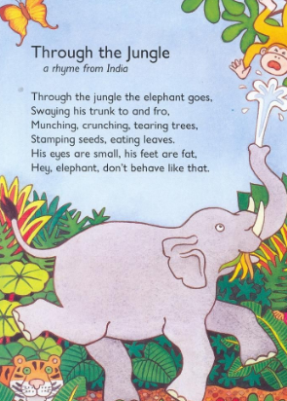 | Magic carpet ride to  somewhere hot |  | Have a go and keep in touch  If you have a go at any of these activities we would love to see what you do. Send a picture or video to stlukes@stlukesprimary.com It may appear in our gallery on the website. Have a look at http://pupils.stlukesprimary.com/gallery.html
 | Rumble in the jungle (English)  Read the story here  https://www.youtube.com/watch?app=desktop&v=D2-O1LkCzpM  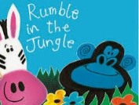  Did you see the terrible tiger and the ravenous rhinoceros. Can you think of words to describe other animals that start with the same sound? Describe your family – daft Dave or funny Fred  Use the internet to find out 3 interesting facts about a jungle animal  What do they eat?  How do they move?  Do they live on the ground or in the trees? |  |  | Ssssspirals Fine motor/Science  Ask an adult to draw a line round a toilet roll tube. Cut/tear along the line to make a curly snake.  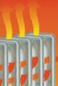  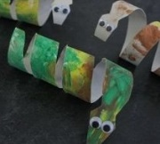  If you are good at cutting try this spiral snake cut from a circle or paper plate  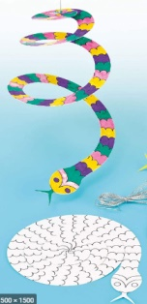  Hang them above a radiator. What makes them turn?

