Ketchup on your cornflakes – English  Read the story  https://www.youtube.com/watch?v=dx6Ox0RbgVI  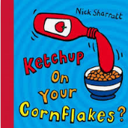  Try mixing some different foods together to see what you like  What goes with custard? Cereal, biscuit, cake?  What goes with jam? Biscuit, bread, chips?  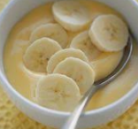  Make a list of the combinations you liked by writing or using photos or symbols | I like it!! – PSED Try a new food and let us know if you liked it | Have a go and keep in touch  If you have a go at any of these activities we would love to see what you do. Send a picture or video to stlukes@stlukesprimary.com It may appear in our gallery on the website. Have a look at http://pupils.stlukesprimary.com/gallery.html
Be a chef – DT
Make a hat from paper.
Do you know what to use to join the paper? Is it string, sellotape, staples, glue?
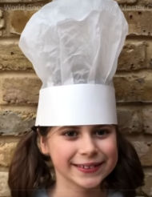
Write your name or stick your picture on.
https://www.google.com/search?q=make+a+chef+hat+from+paper&rlz=1C1CHBF_en-GBGB920GB920&oq=make+a+chef%27s+hat&aqs=chrome.3.0i457j69i57j0i22i30j0i22i30i395l7.6323j1j7&sourceid=chrome&ie=UTF-8#kpvalbx=_xB4IYJC5Es6V8gKp2ZHIDA9
 |  | Food, glorious food  - recipes | Fruit & veg prints – Art  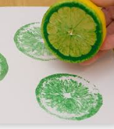  Use some fruit and vegetables to print with.  Can you match the paint colour to the fruit/vegetable? You might have to mix some paints together. How do you make orange?  Can you make a repeating pattern with your fruit – apple, pear, apple, pear etc.
Sing & munch– Music
https://www.youtube.com/watch?v=zHzsY5c9fCk
Sing this cheeseburger song
Do you know any other songs about food?
On top of spaghetti….
Five currant buns….
What others do you know?
 | Tap it out – English/Music  Tap out the syllables in food words  A – pple – pie or toast  How about  Sau - sage and gra - vy  Do any have the same number of syllables as your name? | Sweetie time – DT  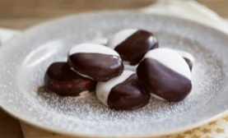  Make some peppermint creams for all your family (don’t forget to keep some for yourself).  https://www.bbcgoodfood.com/recipes/peppermint-creams  What shapes can you make them into? Do they smell nice? Can you choose the right utensil for each task if an adult gives you a choice?  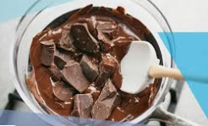  Watch what happens to the chocolate when an adult heats it for you. Do you know what this is called? | Be a chef – PSED/English  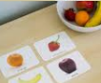  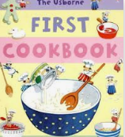  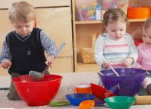  Get out some bowls, pans & spoons and some of Mummy or Daddy’s recipe books. Pretend you are a famous chef and show your family what you are doing. Tell your family what the names of things are and what actions you are doing – bowl, spoon, pan, cup. I’m drinking, pouring, mixing.  Find pictures in the book that are the same as the things you are using. Is there a picture of a baking tray or a cup?
Give us your dough! – Maths
Make some playdough
https://theimaginationtree.com/best-ever-no-cook-play-dough-recipe/
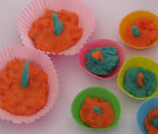
Try making one cake for each cake case or two cherries on each cake. (1:1 correspondence) Make a big sausage roll and cut it into the right number of pieces when an adult writes a number (numeral:quantity matching)
Make biscuits that are square, circle, triangle and rectangle shaped.(shape recognition)
Burn it off- PE
Try this coconut harvest game
https://www.nhs.uk/10-minute-shake-up/shake-ups/pua-and-the-coconut-harvest
Did that get you moving?
