5 a day– DT/ Maths  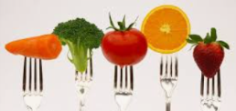  Eating 5 pieces of fruit and veg a day is healthy. Count out 5 fruits – remember to put each one on a plate every time you say the next number and stop when you get to 5. Gather some fruit & veg and see how many ways you can make 5 using 2 different fruits. You can write the ways as number sentences e.g. 2+3=5 or 1+4=5. Now try 3 fruits (1+2+2=5) | Food, glorious food –vegetables. | Careful cookery– DT/PSED  Make a pizza – make your own dough or use a ready-made base or even a pitta. See here for ideas  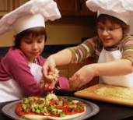  https://www.bbcgoodfood.com/recipes/collection/kids-pizza-recipes  If you are careful, an adult will let you use a grater or a knife (with help) to grate your cheese and slice your mushrooms.  See if you can make a pattern or a face on your pizza. Remember to wash up. | Bop-it– PE  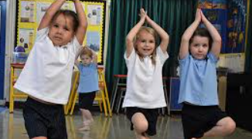  Eating healthy foods like vegetables gives you lots of energy. Play Bop-it where an adult tells you (or shows you) actions and you have to keep doing it until they change the action. Twist it, run it, walk it, hop it, spin it and bop it, which is a jump
Pizza Party - English  Read the story several times. Enjoy the rhythm.  https://www.youtube.com/watch?v=WDlEt2DYQV0  Ask a grown up to read it again without the sound and see if you can remember the rhyming words when they pause.  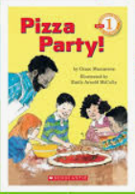  We fill, we…. (stir/spill/eat?) We fix, we….(clean/fun/mix?) | Make a veg- creature Art/DT  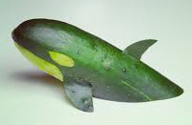  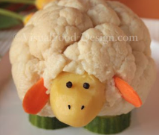  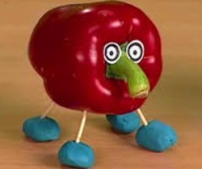  What sort of animal can you make from the vegetables you have? How will you make it stick together? Will it stand up on its own or will you need to lean it against something? Can you use more than one vegetable to make a creature? Give it a name. | Faster, faster – Music  Learn this silly pizza song.  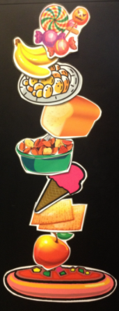  https://www.youtube.com/watch?v=2mzoKmNtNrU  Can you sing it slowly and then get faster? The special word for fast and slow in music is tempo.  It is hard to remember the order. Maybe use real food in a row or pictures to help you. Make up your own verses. | Plant the Tiny Seed English/Science  Read this story and join in with the actions.  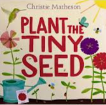  https://www.youtube.com/watch?v=JYMgUvqs-D4  Try planting your own seeds. Bean plants grow quickly. Parents BE CAREFUL Bean seeds are poisonous. Instructions can be found here. https://teaching2and3yearolds.com/how-to-plant-seeds-for-an-easy-kids-gardening-activity/#:~:text=I%20like%20to%20plant%20a,them%20in%20like%20a%20blanket.
Which bowl? -Science  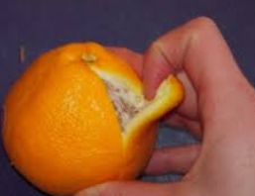  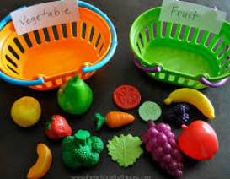  Find several bowls or baskets and sort your food into sets. There are lots of ways you can sort them. Fruit and vegetables, round and not round, different colours, I peel it and I don’t peel it, It’s for dinner and it’s for pudding. Can you think of other ways ?  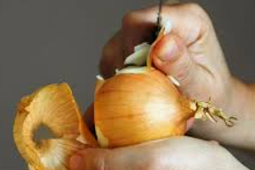 | Foody feet –Art  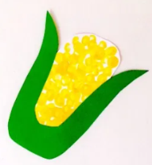  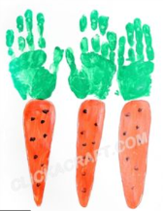  Make some hand ,foot and fingerprints and see what vegetables you can make them into.  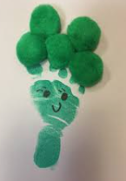  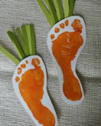  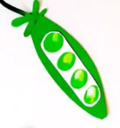 | 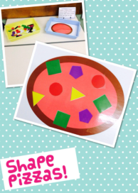  Shape pizza - Maths  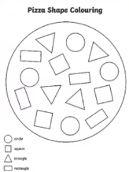  Cut out some shapes and make shape pizzas to order. ‘I want one with 3 triangles, 2 squares and a rectangle please’.  Make one the same as your family by matching shapes to outlines or make it tricky by describing the shapes.’ I want something with 3 sides on my pizza’. | Have a go and keep in touch  If you have a go at any of these activities we would love to see what you do. Send a picture or video to stlukes@stlukesprimary.com It may appear in our gallery on the website. Have a look at http://pupils.stlukesprimary.com/gallery.html

