Ready, set, go– DT/ Maths  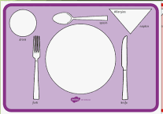  Can you draw round your plate, cup and cutlery to make a place mat. Then see if you can match the items to their shapes. Perhaps you can describe the shapes for your family to guess e.g. it is long and has an oval at the end. | Food, glorious food – at the cafe | Roll up, roll up– DT/PSED/Maths  Make some pancake rolls following this  https://kidsactivitiesblog.com/61826/pancake-roll-ups-kid-style/  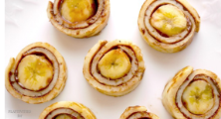  Count how many you have made. How many people live in your house? See how many they can have each (put 1 on each plate and repeat until they are all gone). You can write that as a number sentence 2+2+2+2=8. Have you got any left over? | Pancake races – PE  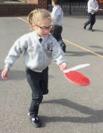  Cut a circle of stiff card (from a cardboard box) just smaller than your smallest frying pan. Practise tossing your pancake. How many times did you drop it? If you practise you will get better.  Have a race with your family – up & down the room with at least 2 tosses.  Try walking, running, walking backwards, walking with one hand on your head. What else can you think of?
Listening lists - English  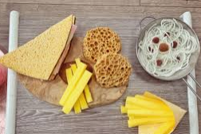  Make some pretend food by drawing/printing and cutting out or by using sponge etc (see this video)https://www.arthurwears.com/2020/04/easy-home-made-pretend-role-play-food-household-items.html ). Your family will tell you 2 things they want e.g. a ham sandwich and a cup of tea. Can you remember them both? Can you get them in order? How about 3? If you want you can write them down to help you or use pictures. | Make a mobile- Art/DT  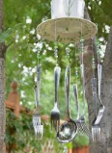  Use a paper plate (or circle of card). Poke some holes around the edge and hang some cutlery from it. How can you make the string stay in place ? Tie a knot, use sellotape or use one piece of string for 2 items? You choose.  Hang it outside or near a window or radiator. Plastic cutlery will move easily and metal cutlery will make a sound. | Doughnutter – Music  Listen to these songs about doughnuts  https://www.youtube.com/watch?v=jA5RQLahG5o  https://www.youtube.com/watch?v=jmWusfay_OY  https://www.youtube.com/watch?v=LYLRon4ppks  Draw a doughnut and hold it up every time you hear the word’ doughnut’ | The Sandwich- English/PSED  Listen to this poem  https://www.youtube.com/watch?v=nGoee7s1ZTY  Make a chart of the things you like and the things you don’t like. (see below)  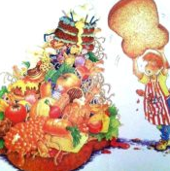  If you have any of these things at home perhaps you could taste them & try something new.
Shake it up -Science  Make a milkshake. Talk about the ingredients and what they look, smell, feel & taste like then see how they change. If you have a blender https://www.bbcgoodfood.com/recipes/collection/milkshake-recipes  If you don’t have a blender https://bakingmischief.com/how-to-make-a-milkshake-without-a-blender/ | Rainbow foods –Art  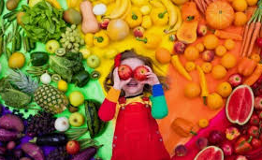  Paint a big rainbow then think of foods for all the different colours. If you have pictures stick them on the right stripe. You could draw or colour some too. Put it up in your pretend café to encourage people to ‘eat the rainbow’  Add some food colouring to uncooked rice, stir & leave to dry. Make patterns with it then sweep it off & start again. | 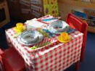  Sell it - Maths  Set out a pretend café and make some menus with things costing between 1p & 10p. See if you can count out thr ight number of coins. How many are left?  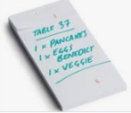  Try selling 2 things and adding those 2 amounts together. You could write it as a number sentence e.g. 2p + 4p = 6p | Have a go and keep in touch  If you have a go at any of these activities we would love to see what you do. Send a picture or video to stlukes@stlukesprimary.com It may appear in our gallery on the website. Have a look at http://pupils.stlukesprimary.com/gallery.html
