Squishing and squashing (Science)  Can you make things change like the corn changed into flour? Try hammering some rice, pine nuts or popcorn into powder. You could squash it between 2 chopping boards & stamp on it. If you have a food processor an adult could help you to use it.  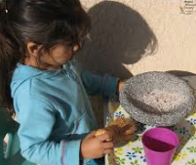  Feel the difference. | Bread sculpture (Art/DT)  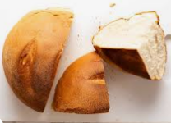  Cut different types of bread into different shapes and leave to dry in a warm place. Make a sculpture with your bread.  Will it stack or do you need to use something to join it?  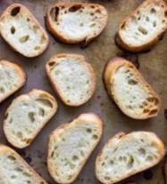  What could you use? |  | Busy hen (PE).  Can you do the actions that the busy red hen had to do all by herself?  You can sweep & dust and polish and carry heavy things.  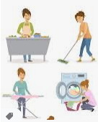  Perhaps you could use an object, picture or word to help you remember, then make up a routine. ‘Dust then sweep 3 times then put the toys away’. |  | Changing solids (Physical)  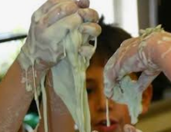  Mix some cornflour & water to a paste. Place in a washing up bowl or tray with an edge (baking tray). Draw patterns with your finger and watch them disappear. Mould it into a ball and see it turn back to liquid. What words do you know – white, hard, runny, sticky, like, don’t like.  Parents – top tip. Leave to dry on hard surfaces and brush off – easier than wiping.
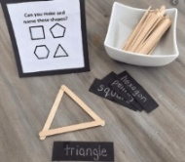
Sticky problems(Maths)
Use a packet of breadsticks to make shapes. Count the sides & vertices (corners). Break some in half to make different shapes. What is the difference between a square and a rectangle?
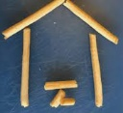
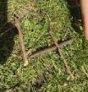
Break some breadsticks and sort them into long and short ones. Can you order them by length and find one longer than your finger or shorter than a spoon?

What else can you make - pictures, numerals, letters? Let us know.
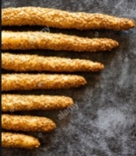
Paint and paste Pics (Art)  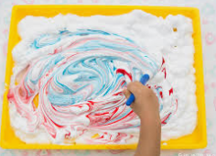  Mix some flour & water to make a paste and spread into some thick paper or card. Lightly paint some stripes of coloured paint on the top. Use your finger or a stick to drag patterns into the dough and paint. Dry in a warm area. |  | Food, glorious food  -bread and flour |  | Storytime (English)  Read the story about making bread.  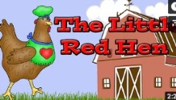  https://www.youtube.com/watch?v=JTCsL26vob4  Can you remember the characters?  Can you make sound effects for each page or animal?  Tell an adult if you like this story or not. |  | Pots and pans band (Music)  Find all the things you used to make bread – bowls, jugs, spoons, baking trays and see what noise you can make. Which makes the loudest noise? Can you copy a pattern that an adult makes – bang, bang, bang stop?  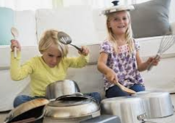
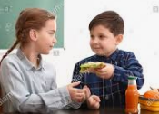
Sharing is caring (PSED)
Can you make some sandwiches for your family? Ask them what they like in them and give one to each.
Bread in a bag  Here’s how to make bread the tidy way!!  https://busytoddler.com/2018/03/make-bread-bag-kids/ |  | Have a go and keep in touch  If you have a go at any of these activities we would love to see what you do. Send a picture or video to stlukes@stlukesprimary.com It may appear in our gallery on the website. Have a look at http://pupils.stlukesprimary.com/gallery.html

