Shape and size sarnies– DT/ Maths  Make some sandwiches and use a knife or cake cutters to make different shapes and sizes. See who wants the big triangle sandwich or the little circle one. They can only eat it if they get it right.  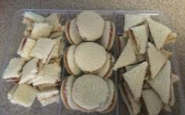 | Food, glorious food - sandwiches | Sort your stuff -Science/Maths  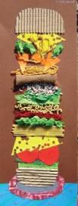  Think of and collect (use pictures if can) all your favourite things. Sort them into things you can eat, things you can play with or other categories. Some of my favourite things are chocolate, hot water bottles, a cup of tea, a book and cheese. I can’t put all my favourite things in a sandwich can I? Make a picture of the silly sandwich you could have. | Find Forky – PE  Remember Forky from Toy Story.  Use a real fork or a picture to play this game  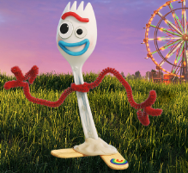  https://www.nhs.uk/10-minute-shake-up/shake-ups/find-forky  Try different actions each time – crawl, jump, slither, walk backwards, bunny hop.
Storytime, Listen English  Read these stories about jam and sandwiches  https://www.youtube.com/watch?v=Sw2NPIYf-IA&t=1s  There are lots of rhyming words in this story. Can you hear them or guess them?  What rhymes with your name?  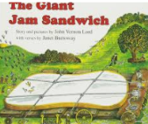  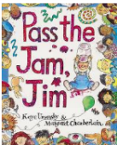  https://www.youtube.com/watch?v=2-HjO3P_IXs  Can your family hide and make a sound like a wasp. I bet if you listen hard you will find them. | Beautiful butties- Art/DT  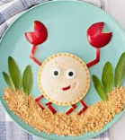  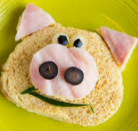  Make an artistic sandwich. Will you use sliced bread, a bread roll or a pitta bread? You can cut out shapes or use different shaped foods.  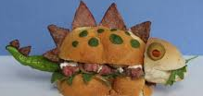  Can you ‘eat a rainbow’? It is really healthy to eat lots of different coloured foods. Send us a picture.  Look at these!! | Repeat the rhythm - Music/Dance  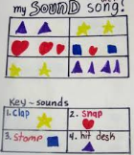  Beat out a simple rhythm e.g. clap, clap, stamp, stamp. Repeat it until you are good. Make another simple rhythm e.g. bang the floor 3 times, pat cheeks. Perhaps make it into a dance. Write or stick shapes or pictures to remind you what to do.  Once you are good try making a rhythm sandwich by playing rhythm 1, followed by rhythm 2 then repeat rhythm 1. | Clean hands- PSED  Practice washing your hands by yourself.  It is really important to have clean hands especially before you touch food.  Sing (to the tune of ‘Knees up Mother Brown’)  1.Wet those dirty hands(X2), With a rub a dub dub and a scrub, scrub, scrub, Wet those dirty hands  2. Soap those dirty hands  3. Rinse those dirty hands  4. Dry those dirty hands.
Lunchbox problems -Science/PSED  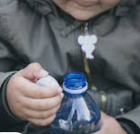  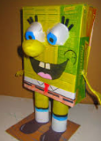  What is in your lunchbox? How can you open the packets or wrappers. Have fun working out how to open crisp packets, juice boxes, cling filmed sandwiches, plastic boxes.  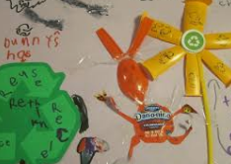  Try wrapping your own sandwich up. Can your family tell you why it has to be completely covered. Make a picture or sculpture with the empty wrappers | Lunch menu – English  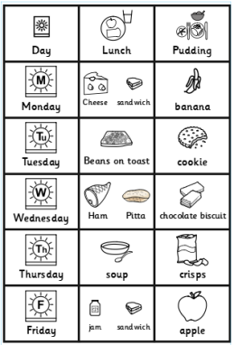  Talk to your family and decide what you can have for lunch this week. Beans on toast, ham sandwich or egg and soldiers. What will be for pudding- fruit, cookie, cake? Make a menu with words, photos or symbols. Ask your teacher for symbols from Kay if you need some. Read your menu each morning so you know what you will be having. | Size sort out - Maths  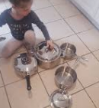  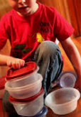  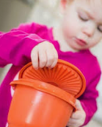  Help your family to sort out the cupboards by getting out all the plastic boxes and working out which lids fit which box or pan. (There is always one left over).  Use words like too big or the names of shapes as you do this. | Have a go and keep in touch  If you have a go at any of these activities we would love to see what you do. Send a picture or video to stlukes@stlukesprimary.com It may appear in our gallery on the website. Have a look at http://pupils.stlukesprimary.com/gallery.html
