Ice, ice baby-Science  Freeze some small toys in some water then ‘free’ them. 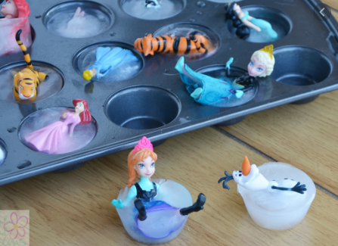  What is the best way?  Try in the fridge, on the windowsill, blow with a hairdryer, leave on the radiator. You could make a chart showing which thaws quickest. | Paint- brrrrr-ushes- (Art)  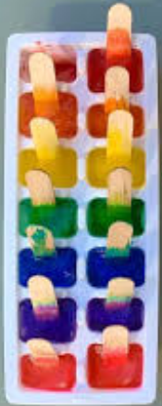  Fill an ice cube tray 1/3 full with paint or food colouring. Add water & mix. Add a stick or spoon to each cube and freeze.  Use them to paint patterns with |  | Little Lost penguin –(ICT)  Log on to  https://www.helpkidzlearn.com/games-igc/play-igc.aspx?id=218&activityid=86&type=igc&category=games  User : Stlukes55  Password: Lucky5  Practice your timing skills by pressing the mouse to help the penguin jump at the right time. |  | Now you see me…Camouflage –(Science)  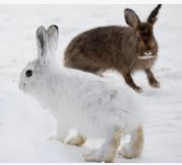  Find toy animals or pictures and put them on a white background. Which ones are difficult to see in the snow? Try different coloured backgrounds to see where animals can hide easily.
 | 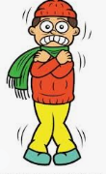  Action!! – (English)  Remember this song.  https://www.youtube.com/watch?v=83aUaYQF4NM  Now make up your own with actions from cold places . Try shiver, ski, slide. What else can you think of. Write/draw the order and get your family to join in. Send us a video!!! |  |  |  | Now freeze – (PE)  Move as fast as you can then freeze!!  https://www.youtube.com/watch?v=388Q44ReOWE  Can you freeze in a wide, snowflake shape or curled like a snowball or tall like an icicle?
The snowkey pokey – (Music)  Have a singalong and play some tinkly, frozen sounds using bells or cutlery. Try this song  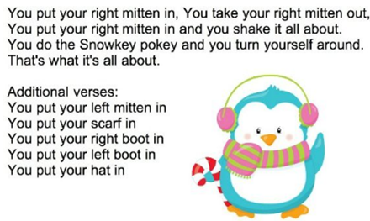  How about ‘Let it go’  https://www.youtube.com/watch?v=iEKLFS-aKcw |  | Dress for the weather –(PSED)  Sort your clothes into warm and cold weather ones. How quickly can you put on your hat, coat, mittens? Can you get faster? Race your family. Can you pull up the zip or do up the buttons?  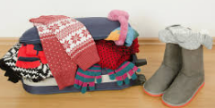 | 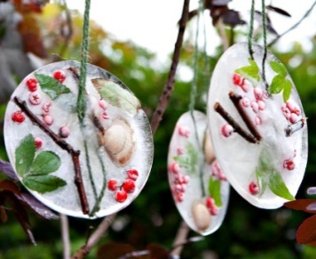  N-ice natured – (Art/English)  Find some natural items, leaves, twigs, flowers, stones in your garden or on your daily exercise (if you are going out) and lay them in a tray of water. If the weather is going to be below freezing, leave them outside (or in your freezer if not). Look at the beautiful ice picture you have made. What words can you use to describe it? |  |  | 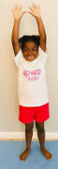
 |  |  | Magic carpet ride to …  somewhere cold here | Have a go and keep in touch  If you have a go at any of these activities we would love to see what you do. Send a picture or video to stlukes@stlukesprimary.com It may appear in our gallery on the website. Have a look at http://pupils.stlukesprimary.com/gallery.html

