Look…..  Look through some family photos, do the children show an interest in photos about others? | Listen….  Go for a sensory walk down your street, you could take photos on your phone and record sounds to revisit and talk about at home. Notice with your child things in the environment stop and feel trees and other sensory items.  ( please note safety first and be aware of not photographing others without permission) |  | Random act of kindness?  Baking can be a really good sensory experience…the smells, tastes, sounds and feelings. Why not bake for a family member and share the love! | Body awareness songs online…  You Tube body songs, head, shoulders knees and toes, one finger one thumb and ten little fingers to name a few!  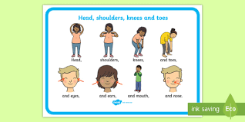
Body awareness
Spend time giving your child a hand or foot massage, this is great for a chill out time and learning about our bodies.
Sing the hand song
Open and shut them, open and shut them,
Give your hands a clap!
Open and shut them, open and shut them put them on your lap.
Open and shut them, open and shut them ,
Give your hands a rub, open and shut them, open and shut them, give yourself a hug!
Post a letter….
Writing” letters” can be a fun activity for children, choosing who to send their letter to, Putting it in the envelope, posting it or simply delivering them around the house. It cheers everyone up receiving a letter. Will they write back?

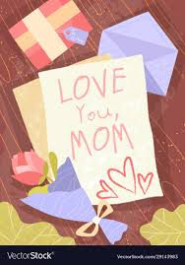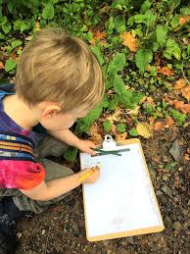
Cress head….  Cress seeds are really easy to pick up from any supermarket they can be planted on damp cotton wool in any container or cup, putting your child’s photo on the front makes a funny cress hair illusion!  Email us if you would like some seeds posting out to you.  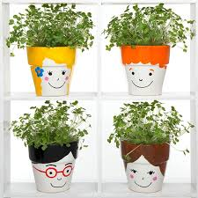 |  | Me, my family and home. |  |  | Share with us…  We would love to share photos with your child at school all about them, their home and family, just email them through!  .
Have a go and keep in touch
There will be additional activities here: http://pupils.stlukesprimary.com/
If you have a go at any of these activities we would love to see what you do. Send a picture or video to stlukes@stlukesprimary.com It may appear in our gallery on the website. Have a look at http://pupils.stlukesprimary.com/gallery.html

